Early Years Foundation Stage

Nursery



Our topics for Early Years 2025-2026
Autumn Term
Lets Explore
Exploring Autumn
Sparkle and Shine

Spring Term
Winter Wonderland
Marvellous Machines

Summer Term
Sunshine and Sunflowers


These topics are carefully planned to cover all aspects of the Early Years curriculum.

We use “In The Moment” Learning.
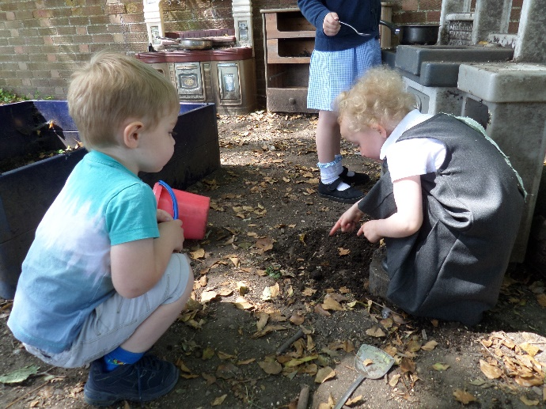
Children are free to choose what activities they do from the carefully planned resources both inside and outside Nursery. Resources are planned in response to children’s interests and following our EYFS topics for the year. Teaching staff join them to support their play, observe, enhance learning by asking thoughtful questions and extend learning by working with the children on their next steps – a “teachable moment.”

How this works.
Each week we will have a certain number of focus children. Over each term we will focus on every child in Nursery.
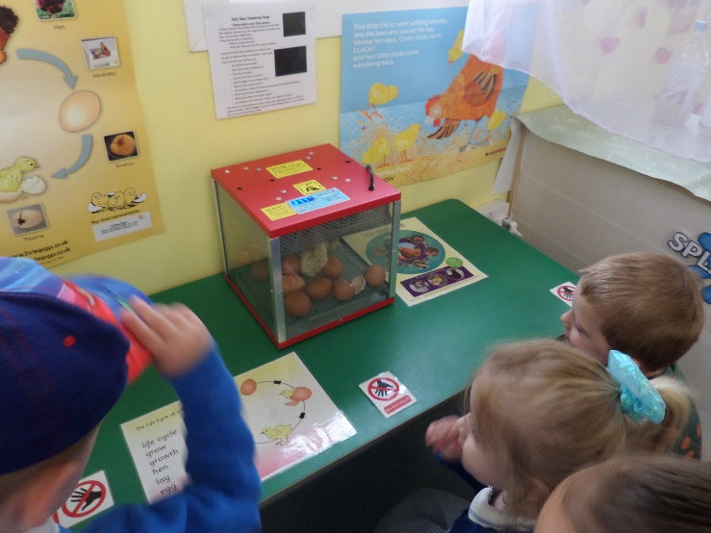
We will send home a sheet for you to complete, asking for your views and information about your child’s current interests. Following the focus week, we will ask you to meet with Mrs Montgomery where you can discuss your child’s learning and next steps.

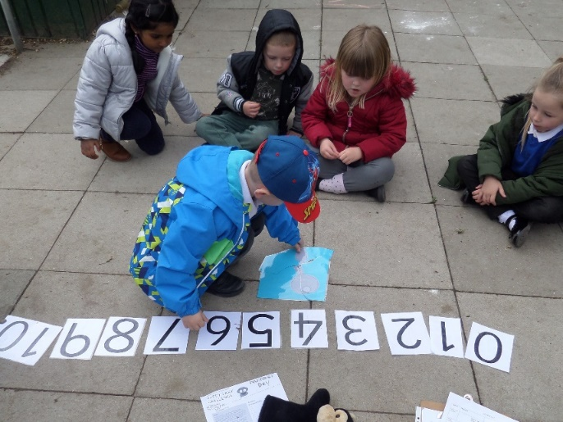
Alongside this….
There will be times when children will sit together for more “formal” adult guided teaching.
These include registration time, phonics and maths, stories and rhymes.
These activities are spread across the week, with the children sitting for short activities at the beginning and end of the session.
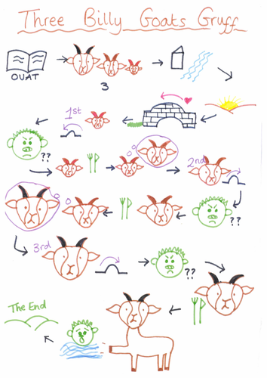
Talk for writing
This is something we follow across the whole school now starting in preschool. It uses oral storytelling and inventing to develop children’s language skills which in turn develops their writing skills later on in school. Shared stories start with rhymes in preschool and journey type stories. In nursery we focus on journey stories then cumulative stories such as Little Red Hen and beat the baddie stories such as Billy Goats Gruff.
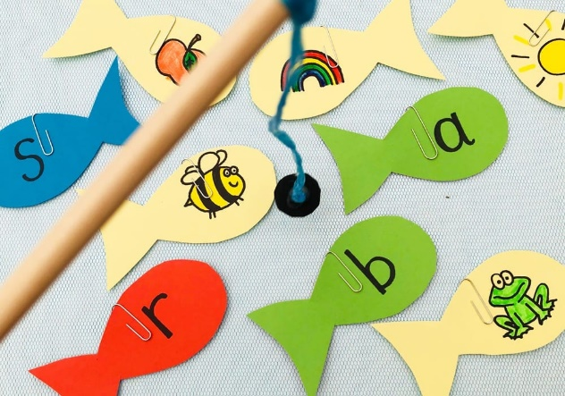
Phonics
In Nursery we teach phonics through the Little Wandle scheme which continues into Reception and Key Stage 1. It is taught in short bursts on a daily basis. We also learn the skills of rhythm and rhyme and think about different sounds in the environment.

Record keeping and assessments
We will keep individual paper files on each child with evidence of learning through observations and focus sheets.
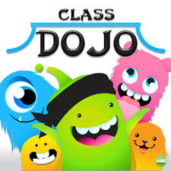
We will send home photos or messages of WOW moments via the class dojo platform.
We will be asking for your input too, you know your children best and this is very valuable to us.

Why work this way?
Play is essential for children’s development, building their confidence as they learn to explore, relate to others, set their own goals and solve problems. Children learn by leading their own play, and by taking part in play which is guided by adults. (Statutory Framework for the Early Years Foundation Stage. 2021)
Children need time to choose their play and other activities freely. High quality resources which are carefully selected and arranged will ensure their play is rich in potential and learning.
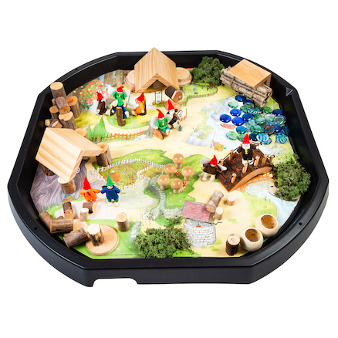
Children also need organised, adult guided learning to bring new ideas and experiences into their lives. (Julien Grenier. 2020) We teach phonics, maths and Talk for Writing through this more adult guided approach in Nursery.

